Cache Me Ousside
Category: Web | Difficulty: Hard

Description
*Cache me ousside. How bow dah?*
Snapshot Uploader out here runnin its mouth: upload a file, some lil background worker renders you a receipt, and you read it back from /results. Da devs think dey slick — dey locked down da endpoint dat *reads* files real tight.
Da one dat *writes* 'em? Yeah... dey wasn't watchin dat one. 👀
Da flag's sittin at /flag.txt and dis service ain't neva servin it to you. You want it? Go catch it ousside.
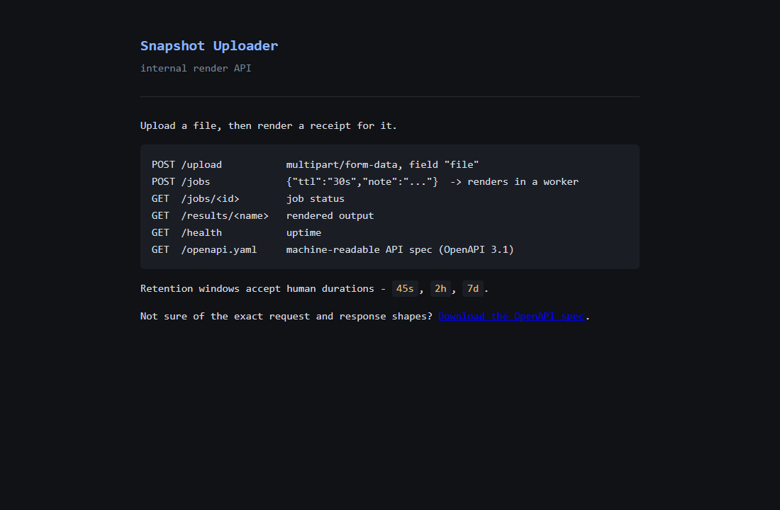
The Snapshot Uploader render API

Files
One hosted Docker container, built from challenge/. From that folder:
cd challenge
docker compose up --build -d # serves http://localhost:8000
A Deno 2 app (challenge/app/): main.ts is the HTTP API, worker.ts is the render worker spawned per job. The flag is baked to /flag.txt (mode 400, owned by the deno user). A difficulty knob VERBOSE_ERRORS (default 0) controls whether render errors leak the worker stack trace — 0 is the intended hard experience. Reference exploit and writeup are in organizer/: solve/solve.py (stdlib only), CHALLENGE.md, SOLUTION.md.

Hint(s)
- The *read* endpoint checks every name you hand it, but nobody's checking what you name the files you *upload*. Dropping bytes on disk is only half of it, though: nothing here reads a random file back to you, so you need a file the service will read back *and run*. What does it start fresh on every single job?
- /app is read-only to the service user, so you can't overwrite worker.ts. What *other* on-disk location holds code the runtime executes — and is owned by that same user?
- It's a Deno app (make an upload fail and read the error class). Deno keeps extracted npm packages in $DENO_DIR (/deno-dir), executed on load with no integrity re-check. Overwrite ms's index.js and trigger one more job.

Walkthrough
A path-traversal arbitrary file write in POST /upload is turned into remote code execution by overwriting an extracted npm dependency in Deno's on-disk module cache. Each render job spawns a fresh worker that re-imports that dependency from disk, so the next job runs attacker code — which reads /flag.txt and drops it where /results/ will serve it. No restart, no lockfile patching.
- Recon. The landing page lists five routes: POST /upload (multipart, field file), POST /jobs (renders a receipt in a worker), GET /jobs/<id>, GET /results/<name>, GET /health. The uploaded file *content* is never used by the renderer — only note and ttl reach the receipt — so there's no file-read sink: you need code execution. And GET /results/<name> is strictly validated (^[A-Za-z0-9._-]{1,64}$, rejects ..), so the read side can't reach /flag.txt.
- The write primitive. POST /upload concatenates the attacker-controlled multipart filename onto the upload dir with no sanitization, so ../ escapes it. Writing into the results directory and reading it back confirms arbitrary write — while the read side stays locked down:
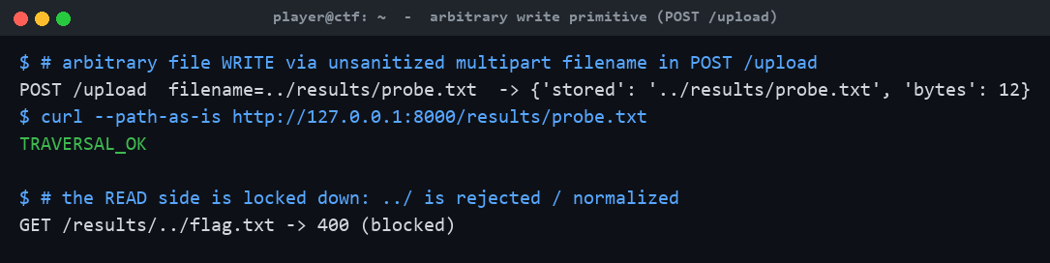
Path traversal write via POST /upload; read side blocked
- Find writable *code*. /app is read-only to the service user, so worker.ts can't be touched. Fingerprinting the runtime (a failed upload returns Deno's <ErrorClass>: <msg> (os error N) format) identifies Deno, whose module cache lives in $DENO_DIR (/deno-dir) and *is* writable by the runtime user. Both entrypoints import ms from "ms", extracted at /deno-dir/npm/registry.npmjs.org/ms/2.1.3/index.js.
- Poison the cached module. Overwrite that index.js via the traversal with a replacement that reads /flag.txt into the served results dir on import, while still exporting a working ms() so the render reports done. Deno never re-verifies extracted npm files (the lockfile integrity is a sha512 over the *tarball*, checked only at extract time).
- Trigger and read. The long-running API keeps its in-memory ms, but every POST /jobs spawns a fresh worker that re-reads the module from disk — so one more job runs the payload, with no restart. The flag lands in /results/pwned.txt. The reference solver performs the whole chain:
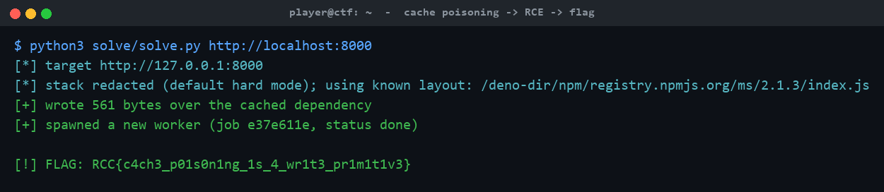
solve.py: traversal write -> cache poisoning -> RCE -> flag

Flag
RCC{c4ch3_p01s0n1ng_1s_4_wr1t3_pr1m1t1v3}

